Owl Banding at Indiana Dunes State Park!
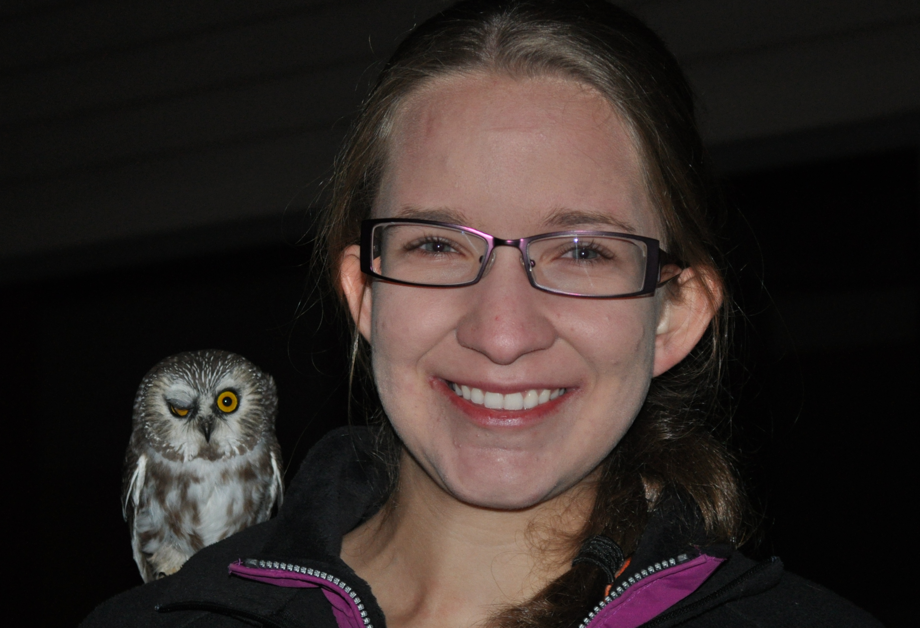
Join us this fall for our fifth year of saw-whet owl banding in the Indiana Dunes State Park! The owl banding program is run from roughly October 10 to November 10, for 4-8 hours each night starting one-half hour after sunset. Banding is weather dependent, and visitors are welcome to call the Nature Center to check on nightly banding updates. Public presentations are given on October 25, 26, 27, and November 2 as well. Help release an owl through our owl adoption program that supports the materials and supplies needed to make this program happen! For more information, call the Nature Center at 219-926-1390.

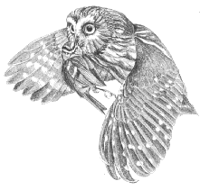
Indiana Dunes State Park
Saw-whet Owl Adoption Program
Supporting research on the migration patterns
of the Northern Saw-whet Owl in the Indiana Dunes.
__ Yes, I would like to support Saw-whet Owl research and other NIMBA Projects!
Name: ______________________________________________________________
Address: ____________________________________________________________
City: __________________________ State: ______________ Zip: _____________
Phone: ________________________ Email: _______________________________
___Yes ___ No Others (school classes, individuals, etc…) may also adopt my owl to assist in fundraising to support this research.
Send cash or check with $25 for each Northwest Indiana Migratory Bird Association
Adopted owl payable to: 1600 N 25 E Chesterton, IN 46304
In return you will receive a detailed letter and certificate about the owl you have adopted.
Contact Brad Bumgardner (bbumgardner@dnr.in.gov) for more information.

